1. Random Forest Classifier — Effect of Trees and Maximum Depth
Program Code
import numpy as np
import pandas as pd
import matplotlib.pyplot as plt
from sklearn.datasets import load_breast_cancer
from sklearn.model_selection import train_test_split
from sklearn.ensemble import RandomForestClassifier
from sklearn.tree import DecisionTreeClassifier
from sklearn.metrics import (
accuracy_score,
precision_score,
recall_score,
f1_score
)
data = load_breast_cancer()
X = data.data
y = data.target
X_train, X_test, y_train, y_test = train_test_split(
X, y,
test_size=0.2,
random_state=42,
stratify=y
)
tree_values = [10, 50, 100, 200]
results = []
for n_trees in tree_values:
model = RandomForestClassifier(
n_estimators=n_trees,
max_depth=None,
random_state=42
)

model.fit(X_train, y_train)
y_pred = model.predict(X_test)
results.append([
n_trees,
accuracy_score(y_test, y_pred),
precision_score(y_test, y_pred),
recall_score(y_test, y_pred),
f1_score(y_test, y_pred)
])
results_df = pd.DataFrame(
results,
columns=[
"Trees",
"Accuracy",
"Precision",
"Recall",
"F1-Score"
]
)
print("\nRandom Forest - Varying Number of Trees")
print(results_df.round(4))
depth_values = [2, 4, 6, 8, None]
depth_results = []
for depth in depth_values:
model = RandomForestClassifier(
n_estimators=100,
max_depth=depth,
random_state=42
)
model.fit(X_train, y_train)
y_pred = model.predict(X_test)

depth_results.append([
str(depth),
accuracy_score(y_test, y_pred),
precision_score(y_test, y_pred),
recall_score(y_test, y_pred),
f1_score(y_test, y_pred)
])

depth_df = pd.DataFrame(
depth_results,
columns=[
"Max Depth",
"Accuracy",
"Precision",
"Recall",
"F1-Score"
]
)
print("\nRandom Forest - Varying Maximum Depth")
print(depth_df.round(4))
dt = DecisionTreeClassifier(
random_state=42
)
dt.fit(X_train, y_train)
dt_pred = dt.predict(X_test)
print("\nSingle Decision Tree Performance")
print("Accuracy :", round(accuracy_score(y_test, dt_pred), 4))
print("Precision:", round(precision_score(y_test, dt_pred), 4))
print("Recall :", round(recall_score(y_test, dt_pred), 4))
print("F1-Score :", round(f1_score(y_test, dt_pred), 4))
plt.figure(figsize=(8, 5))
plt.plot(
results_df["Trees"],
results_df["Accuracy"],
marker="o"
)
plt.xlabel("Number of Trees")
plt.ylabel("Accuracy")
plt.title("Random Forest: Number of Trees vs Accuracy")
plt.grid(True)
plt.show()
Sample Output:
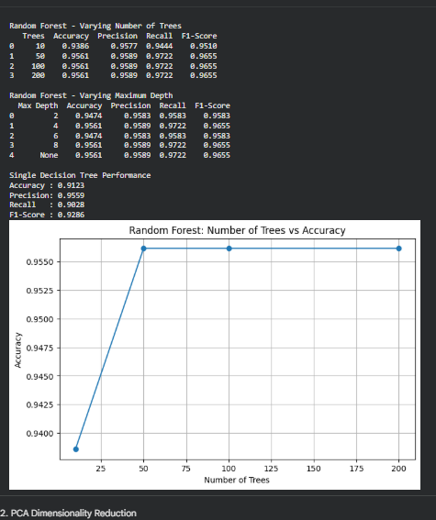

2. PCA Dimensionality Reduction
Program Code
import time
import numpy as np
import pandas as pd
import matplotlib.pyplot as plt
from sklearn.datasets import load_digits
from sklearn.model_selection import train_test_split
from sklearn.preprocessing import StandardScaler
from sklearn.decomposition import PCA
from sklearn.linear_model import LogisticRegression
from sklearn.metrics import accuracy_score
digits = load_digits()
X = digits.data
y = digits.target
print("Original number of features:", X.shape[1])

scaler = StandardScaler()
X_scaled = scaler.fit_transform(X)

X_train, X_test, y_train, y_test = train_test_split(
X_scaled,
y,
test_size=0.2,
random_state=42,
stratify=y
)
components = [5, 10, 20, 30, 40, 64]
results = []
for n in components:
start = time.time()
pca = PCA(n_components=n)
X_train_pca = pca.fit_transform(X_train)
X_test_pca = pca.transform(X_test)
model = LogisticRegression(
max_iter=2000,
random_state=42
)
model.fit(X_train_pca, y_train)
y_pred = model.predict(X_test_pca)
end = time.time()
accuracy = accuracy_score(y_test, y_pred)
variance = np.sum(pca.explained_variance_ratio_)
results.append([
n, variance, accuracy,
end - start
])

results_df = pd.DataFrame(
results,
columns=[
"Components",
"Variance Retained",
"Accuracy",
"Time (sec)"
]
)
print("\nPCA Experiment Results")
print(results_df.round(4))
plt.figure(figsize=(8, 5))
plt.plot(
results_df["Components"],
results_df["Accuracy"],
marker="o"
)
plt.xlabel("Number of Principal Components")
plt.ylabel("Accuracy")
plt.title("PCA Components vs Classification Accuracy")
plt.grid(True)
plt.show()
plt.figure(figsize=(8, 5))

plt.plot(
results_df["Components"],
results_df["Variance Retained"],
marker="o"
)

plt.xlabel("Number of Principal Components")
plt.ylabel("Variance Retained")
plt.title("PCA Components vs Variance Retained")
plt.grid(True)
plt.show()
Sample Output:
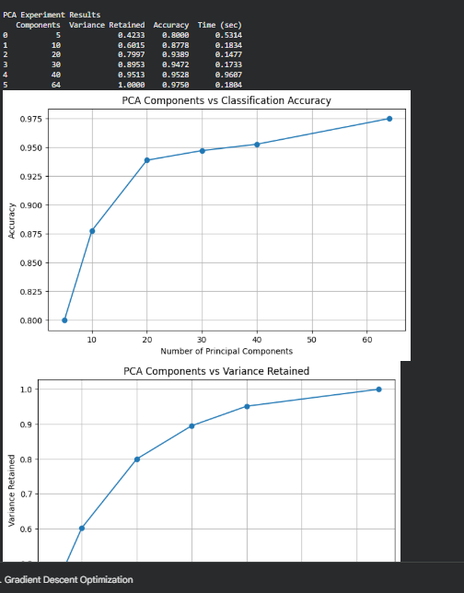

3. Gradient Descent Optimization
Program Code
import numpy as np
import matplotlib.pyplot as plt
# Objective function
# f(x) = x^2
# Gradient = 2x
# Minimum occurs at x = 0
def gradient_descent(
learning_rate,
initial_x,
tolerance=1e-6,
max_iterations=10000
):
x = initial_x
history = []
for i in range(max_iterations):
function_value = x ** 2
history.append(function_value)
gradient = 2 * x
new_x = x - learning_rate * gradient
if abs(new_x - x) < tolerance:
x = new_x
history.append(x ** 2)
return x, history, i + 1
x = new_x
return x, history, max_iterations
learning_rates = [
0.001,
0.01,
0.1,
0.5,
1.1
]
initial_x = 10
print("\nGradient Descent Results")
print("-" * 60)
for lr in learning_rates:
final_x, history, iterations = gradient_descent(
lr,
initial_x
)
print(
"Learning Rate:",
lr,
"| Final x:",
round(final_x, 6),
"| Iterations:",
iterations
)
plt.figure(figsize=(8, 5))
for lr in learning_rates:
final_x, history, iterations = gradient_descent(
lr,
initial_x
)
plt.plot(
history[:100],
label="LR = " + str(lr)
)
plt.xlabel("Iteration")
plt.ylabel("f(x) = x²")
plt.title("Gradient Descent Convergence")
plt.legend()
plt.grid(True)
plt.show()
initial_values = [-20, -10, 5, 10, 20]
print("\nEffect of Initialization")
print("-" * 60)
for init in initial_values:
final_x, history, iterations = gradient_descent(
learning_rate=0.1,
initial_x=init
)
print(
"Initial x:",
init,
"| Final x:",
round(final_x, 6),
"| Iterations:",
iterations
)
Sample Output
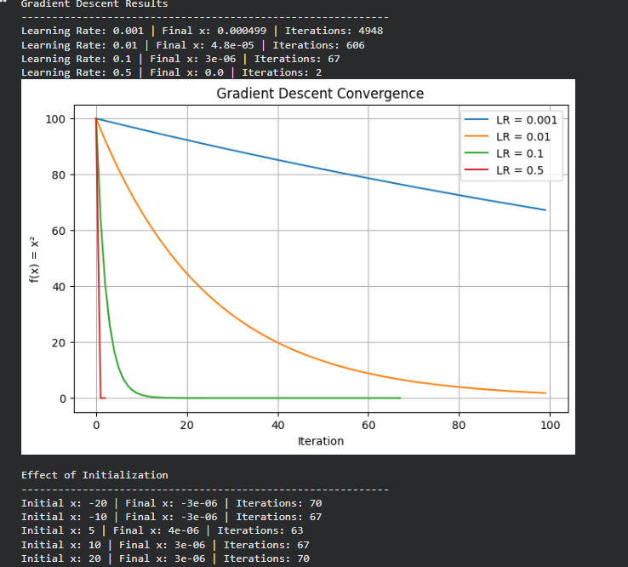

4. Neural Network Classifier
Program Code
import numpy as np
import matplotlib.pyplot as plt
from sklearn.datasets import load_digits
from sklearn.model_selection import train_test_split
from sklearn.preprocessing import StandardScaler
from sklearn.neural_network import MLPClassifier
from sklearn.metrics import accuracy_score
digits = load_digits()
X = digits.data
y = digits.target
scaler = StandardScaler()
X = scaler.fit_transform(X)
X_train, X_test, y_train, y_test = train_test_split(
X,
y,
test_size=0.2,
random_state=42,
stratify=y
)
architectures = [
(20,),
(50,),
(50, 25),
(100, 50),
(100, 50, 25)
]
results = []
for architecture in architectures:
model = MLPClassifier(
hidden_layer_sizes=architecture,
activation="relu",
solver="adam",
max_iter=300,
random_state=42
)
model.fit(X_train, y_train)
y_pred = model.predict(X_test)
accuracy = accuracy_score(
y_test,
y_pred
)
results.append([
str(architecture),
accuracy,
len(model.loss_curve_)
])
results_df = []
for architecture in architectures:
model = MLPClassifier(
hidden_layer_sizes=architecture,
activation="relu",
solver="adam",
max_iter=300,
random_state=42
)
model.fit(X_train, y_train)
y_pred = model.predict(X_test)
results_df.append([
architecture,
accuracy_score(y_test, y_pred),
len(model.loss_curve_)
])

print("\nNeural Network Architecture Results")
print("-" * 65)
for row in results_df:
print(
"Architecture:",
row[0],
"| Accuracy:",
round(row[1], 4),
"| Iterations:",
row[2]
)
activations = ["relu", "tanh", "logistic"]
print("\nActivation Function Comparison")
print("-" * 65)
for activation in activations:
model = MLPClassifier(
hidden_layer_sizes=(100, 50),
activation=activation,
solver="adam",
max_iter=300,
random_state=42
)
model.fit(X_train, y_train)
y_pred = model.predict(X_test)
accuracy = accuracy_score(
y_test,
y_pred
)

print(
"Activation:",
activation,
"| Accuracy:",
round(accuracy, 4),
"| Iterations:",
len(model.loss_curve_)
)
model = MLPClassifier(
hidden_layer_sizes=(100, 50),
activation="relu",
solver="adam",
max_iter=300,
random_state=42
)
model.fit(X_train, y_train)
plt.figure(figsize=(8, 5))
plt.plot(model.loss_curve_)
plt.xlabel("Iteration")
plt.ylabel("Loss")
plt.title("Neural Network Training Loss")
plt.grid(True)
plt.show()
Sample Output
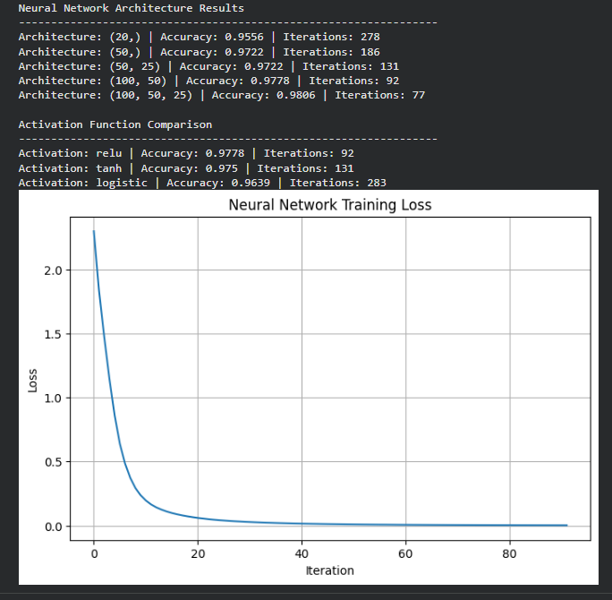

5. Hierarchical Clustering — Linkage Comparison
Program Code
import numpy as np
import matplotlib.pyplot as plt
from sklearn.datasets import make_blobs
from sklearn.preprocessing import StandardScaler
from sklearn.cluster import AgglomerativeClustering
from sklearn.metrics import silhouette_score
from scipy.cluster.hierarchy import (
dendrogram,
linkage
)
X, _ = make_blobs(
n_samples=300,
centers=3,
cluster_std=1.2,
random_state=42
)
# Standardize data
X = StandardScaler().fit_transform(X)
linkage_methods = [
"single",
"complete",
"average"
]
print("\nHierarchical Clustering Results")
print("-" * 60)
for method in linkage_methods:
clustering = AgglomerativeClustering(
n_clusters=3,
linkage=method
)
labels = clustering.fit_predict(X)
score = silhouette_score(
X,
labels
)
print(
"Linkage:",
method,
"| Silhouette Score:",
round(score, 4)
)
for method in linkage_methods:
Z = linkage(
X,
method=method
)
plt.figure(figsize=(9, 5))
dendrogram(
Z,
truncate_mode="lastp",
p=30
)
plt.title(
"Hierarchical Clustering Dendrogram - "
+ method.capitalize()
+ " Linkage"
)

plt.xlabel("Cluster / Sample")
plt.ylabel("Distance")
plt.show()
for method in linkage_methods:
clustering = AgglomerativeClustering(
n_clusters=3,
linkage=method
)
labels = clustering.fit_predict(X)
plt.figure(figsize=(7, 5))
plt.scatter(
X[:, 0],
X[:, 1],
c=labels
)
plt.title(
"Clusters using "
+ method.capitalize()
+ " Linkage"
)
plt.xlabel("Feature 1")
plt.ylabel("Feature 2")
plt.show()
Sample Output:
